**WEB APPLICATION ATTACKS AND SAFETY MEASURES**

Akhila Parankusham

Tagliatela College of Engineering, University of New Haven,

[CSCI-6658-01](https://canvas.newhaven.edu/courses/20012): Ethical Hacking.

Professor: Greg Kyrytschenko

December 2023

**ABSTRACT**

Web application attacks, which include a variety of approaches aimed at exploiting weaknesses in web-based systems, pose a constant and expanding danger to Internet security. cross-site scripting (XSS), SQL injection, and Distributed Denial of Service (DDoS) are examples of attacks that target flaws in web applications, potentially resulting in data breaches, service interruptions, and unauthorized access. Countermeasures, on the other hand, are an essential defense mechanism against these harmful invasions. To fortify online applications against potential breaches and limit the impact of cyberattacks, countermeasures take a holistic strategy that includes robust security protocols, regular updates, and proactive techniques. Exploration of Multifaceted Web Assaults analyzes their tactics and outlines viable remedies critical in protecting digital assets, assuring resilience, and maintaining the integrity of web-based systems in an ever-changing cyber world.

**Table of Contents**

**Abstract………………………………………………………………………….………...……1**

**Introduction…………………………………………………………………………………….3**

**History…………………………………………………………………………………………..3**

**Usage……………………………………………………………………………………………3**

**Web Server Attacks……………………………………………………………………………3**

**Web Server Operations………………………………………………………………………..4**

**Web Server Components……………………………………………………………………...4**

**Web Server Security Issues…………………………………………………………………...5**

**Impact of Web Server Attacks………………………………………………………….…….5**

**Different Web Server Attacks………………………………………………………….……..6**

**Web Server Attack Tools………….…………………………………………………….…….6**

**Web Server Countermeasures………………………………………………………….……..7**

**Web Application Attacks……………………………………………………………….……..7**

**How Web Application Works………………………………………………………….….….8**

**Web Application Architecture………………………………………………………….…….9**

**Web Services………………………….……………………………………….……………….9**

**Web Service Architecture………….………………………………………….……………....9**

**Characteristics of Web Services……………………………………………………………..10**

**Types of Web Services………………………………………………………………………..10**

**Web Application Threats and Attacks………………………………………………………11**

**Web Application Attack Tools……………………………………………………………… 12**

**Web Application Attacks Countermeasures………………………………………………..12**

**Web Application Security Testing Tools……………………………………………………13**

**Future Scope………………………………………………………………………………….14**

**Recommendations……………………………………………………………………………14**

**Conclusion…………………………………………………………………………………….14**

**References…………………………………………………………………………………….15**

**Introduction**

Web apps have changed technology by making services available to people all over the world. However, greater connectivity creates vulnerabilities that smart threat actors can exploit. They employ a variety of techniques, including injecting malicious inputs, social engineering for password acquisition, and attacking backend architecture. Cross-site scripting, which is difficult to prevent, is still a risk. API architecture also creates dangers owing to exposed client rights. Comprehensive defenses, such as human-led penetration tests and stringent credential hygiene, are essential. Micro-segmentation and service mesh architectures prevent successful attacks on important assets. (https://owasp.org/).

To combat attacks such as SQL injection, secure coding standards such as rigorous validation and input sanitization are critical. Unauthorized access is reduced via strong authentication and access controls. WAFs (Web Application Firewalls) are the first line of security, monitoring traffic and blocking any threats. Penetration testing and security audits on a regular basis ensure continuing resistance against evolving threats. User education fosters a security-conscious culture, assisting in the detection and reporting of anomalies. A multi-layered security strategy that includes patch management, continuous monitoring, and adherence to standards such as OWASP fortifies web applications against dynamic attacks while stressing data protection, application integrity, and user confidence in the interconnected digital ecosystem. (https://owasp.org/).

**History**

Web application attacks have undergone a significant evolution since the late 1990s, starting with the emergence of web applications and their vulnerabilities. Early instances like the Morris Worm in 1988 set the stage for cyber threats. Throughout the 2000s, attacks such as Code Red, Nimda worms, and SQL injection exploits showcased the susceptibility of web servers, leading to widespread disruptions. During the mid-2000s, Cross-Site Scripting (XSS) gained prominence alongside escalated concerns over the dissemination of web-based malware and the proliferation of phishing tactics. The following decade highlighted major data breaches exposing millions of user credentials, along with the emergence of mobile app vulnerabilities. Recent years emphasized API security, supply chain attacks, and sophisticated breaches, underscoring the complex nature of modern attacks targeting interconnected systems. Throughout this history, the evolution of technology has driven the expansion and sophistication of web application attacks, necessitating continual advancements in cybersecurity practices to defend against these dynamic and persistent threats. (<https://www.sans.org>).

**Usage**

In cyberspace, web application assaults provide a persistent threat by taking advantage of weaknesses to breach systems and data. Organizations use a variety of countermeasures, including strict authentication procedures, constant security testing, and strong input validation, to combat these risks. The effectiveness of these remedies depends on preventative actions like patch management, secure code, and user training. Furthermore, when attack vectors change, defense methods must also adapt and remain vigilant to successfully minimize risks and protect against new and emerging threats. (<https://www.sans.org>).

**Web Server Attacks**

Web server attacks, such as DDoS attacks that cause service outages, SQL injection that targets databases for data extraction, and XSS that exploits browsers with malicious code, all pose a threat to the integrity of online services. Misconfigurations on the server, such as directory traversal, jeopardize data security even further. To protect web server architecture from emerging threats, robust solutions such as frequent updates, secure setups, and strict access controls are essential. (Ethical Hacking Essentials, EC-Council).

**Web Server Operations**

A web server serves as the central hub for storing and delivering web content globally via HTTP. It acts as a go-between for clients and the desired resources. The server processes client requests for web content over HTTP, obtains data from its storage or dedicated application servers, and creates appropriate responses. If the requested data is not accessible, the server sends error messages, keeping the interactive cycle going for easy access to online resources and efficient client-server communication. (Ethical Hacking Essentials, EC-Council).

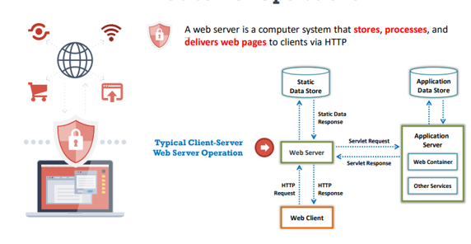 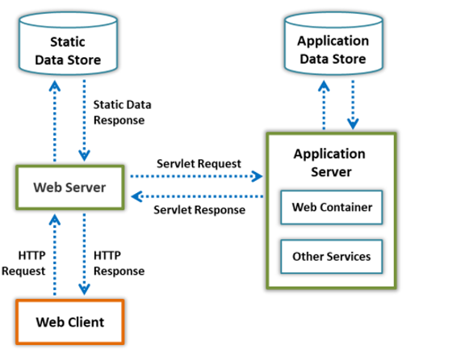

**Figure 1: Web Server Operations Figure 2: Client–Server Communication**

**in Web Server Operations**

**Web Server Components**

**Document Root:** Holds vital HTML files for a domain, responds to requests, and serves as the primary content repository.

**Server Root:** The top-level directory for server management, containing server configurations, error logs, executables, and implementation code.

**Virtual Document Tree:** Serves as supplementary storage when disk capacity is limited, allowing object-level security and different search pathways.

**Virtual Hosting:** Virtual Hosting permits multiple domains to share a single server, facilitating resource sharing and diverse hosting methodologies.

**Web Proxy:** A Web Proxy, positioned between clients and servers, forwards requests, serving to avert IP blocking and ensuring client anonymity (Ethical Hacking Essentials, EC-Council).

**Web Server Security Issues**

Web servers that have security flaws due to obsolete software and incorrect configurations run a severe risk of experiencing disruptions in service and data breaches. These hazards are increased by negligent management of personal information and insufficient encryption. To counter emerging threats, strengthening defenses requires a complete approach that includes stringent access controls, regular updates, robust security standards, and safe coding techniques. (Ethical Hacking Essentials, EC-Council).

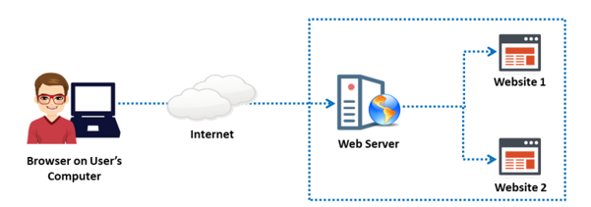

**Figure 3: Conceptual diagram of a web server: The user visits websites hosted on a web server**

**Impact of Web Server Attacks**

* **Compromise of User Accounts:** Attacking web servers often aims to compromise user accounts, providing attackers with valuable information. Once compromised, these accounts serve as launching pads for further attacks on the web server.
* **Website Defacement:** Attackers can alter a website's appearance entirely, replacing original content with their own visuals and messages. This defacement undermines the site's credibility and can convey malicious intent.
* **Secondary Attacks and Root Access:** Compromising a web server grants attackers opportunities for secondary attacks on other websites or client systems. Gaining root access, the highest level of server privilege, offers unrestricted control, enabling any form of manipulation.
* **Data Tampering and Theft:** Attackers can manipulate, delete, or replace web server data, potentially injecting malware to compromise users accessing the server. This tampering can result in data theft, compromising sensitive records or proprietary information.
* **Reputation Damage:** Web server attacks may expose customer information, tarnishing a company's reputation. Public exposure of customer data erodes trust, leading to a loss of confidence in the company, and impacting its brand image.

These impacts highlight the multifaceted dangers posed by web server attacks, ranging from immediate technical compromises to lasting reputational damage for organizations. (Ethical Hacking Essentials, EC-Council).

**Different Web Server Attacks**

* **SQL** **Injection (SQLi):** Attackers inject malicious SQL queries through input fields on websites, exploiting vulnerabilities in database query construction to gain unauthorized access, manipulate data, or execute commands.
* **Cross-Site Scripting (XSS):** This attack injects malicious scripts into web pages viewed by other users. It can hijack user sessions, steal cookies, or perform other malicious activities by executing scripts within the victim's browser.
* **DDoS (Distributed Denial of Service):** This attack floods a web server with an overwhelming volume of traffic from multiple sources, rendering it inaccessible to legitimate users and causing service disruption.
* **Directory Traversal:** Attackers exploit insufficient input validation to navigate through file directories, accessing restricted files or directories to retrieve sensitive information.
* **Server-Side Request Forgery (SSRF):** Exploiting a web app's trust in server-side requests, attackers manipulate the server to make unauthorized requests, risking data exposure or further network breaches.
* **Remote Code Execution (RCE):** Leveraging vulnerabilities to execute code remotely on the web server, granting unauthorized control and potentially compromising its security.
* **File Inclusion Attacks:** Exploiting weaknesses to include malevolent files from external sources, allowing attackers to execute unauthorized code or access sensitive server files.
* **HTTP Response Splitting:** Manipulating HTTP responses to inject malicious content, granting attackers the ability to execute attacks like cookie poisoning, cache poisoning, or redirecting users to malicious sites.
* **Brute Force Attacks:** Cybercriminals attempt various username and password combinations to gain unauthorized access to networks, repeatedly attempting different credentials until they uncover the perfect login information to breach server security.
* **Zero-Day Exploits:** These attacks target previously unknown vulnerabilities (zero-day vulnerabilities) in web server software before developers release patches or fixes to address them. (Ethical Hacking Essentials, EC-Council).

**Web Server Attack Tools**

Metasploit Framework: Empowering cyber security professionals with a versatile toolkit for penetration testing, exploit development, and research, featuring an extensive array of operational remote exploits across diverse platforms. It includes a wide range of operational remote exploits for various platforms. Metasploit automates the exploitation of web servers by capitalizing on known vulnerabilities and weak passwords in protocols like Telnet, SSH, HTTP, and SNMP. Closed-loop vulnerability validation, phishing simulations, social engineering, manual brute forcing, exploitation, and evasion of protective solutions are among its capabilities. It enables pen testers to do jobs fast, analyze security across systems, and create results for in-depth research.

Other Web Server Attack Tools:

Immunity's CANVAS: (<https://www.immunitinc.com>)

THC Hydra: (<https://github.com>)

HULK DoS: (<https://github.com>)

MPack: (<https://sourceforge.net>)

w3af: (<https://w3af.org>)

These additional tools provide a variety of functionalities for assessing vulnerabilities, launching attacks, and testing web server security servers and systems.

**Web** **Server Countermeasures**

* **Regular Updates and Patching:** Consistently apply updates to web server software and plugins, mitigating potential vulnerabilities and fortifying server defenses against exploitation risks.
* **Secure Configurations:** Implement secure settings, including strong passwords, minimal service exposure, and disabling unnecessary features to reduce attack surfaces.
* **Firewalls and Intrusion Detection/Prevention Systems:** Deploy firewalls to filter incoming traffic and intrusion detection/prevention systems to detect and block malicious activities, bolstering defense mechanisms.
* **Encryption and HTTPS:** Employ SSL/TLS encryption protocols, implementing HTTPS to safeguard data during transmission, shielding sensitive information from interception and manipulation attempts.
* **Web Application Firewalls (WAFs):** Employ WAFs to inspect and filter HTTP traffic, identifying and mitigating common web application threats like SQL injection and XSS attacks.
* **Regular Backups:** Maintain frequent backups of web server data to restore in case of a successful attack or data corruption, ensuring business continuity and minimizing potential losses.
* **Security Audits and Penetration Testing:** Conduct regular security audits and penetration tests to identify vulnerabilities, weaknesses, and misconfigurations, enabling proactive mitigation.
* **User Authentication and Access Control:** Implement strong authentication mechanisms, including multi-factor authentication, and strict access controls to limit privileges and mitigate unauthorized access risks.
* **Monitoring and Logging:** Employ robust monitoring tools to track server activities and comprehensive logging to detect suspicious behavior or potential security incidents.
* **Security Awareness Training:** Educate personnel on cybersecurity best practices to foster a security-conscious culture, empowering them to recognize and report potential threats or suspicious activities.

Implementing these countermeasures collectively fortifies web server defenses, reducing the likelihood of successful attacks and enhancing overall security posture. (Ethical Hacking Essentials, EC-Council).

**Web Application Attacks**

Web application attacks are diverse, exploiting vulnerabilities in web systems through techniques like SQL injection, XSS, and flawed authentication. These assaults jeopardize data integrity and user privacy, necessitating proactive defense measures. Combating these threats requires secure coding, regular audits, robust security frameworks, and user education to thwart evolving attack strategies and safeguard web-based systems. (Ethical Hacking Essentials, EC-Council).

* **Platform Independence:** Web applications are not tied to specific operating systems, simplifying their development and troubleshooting processes while minimizing associated costs.
* **Universal Accessibility:** They offer round-the-clock access from any location using an internet-connected device, ensuring convenience and availability for users.
* **Customizable User Interface:** The user interface is easily
* adaptable, enabling swift updates and modifications as per evolving needs.
* **Device Compatibility:** Web applications are accessible across various devices with internet browsers, including smartphones and PDAs, ensuring broad accessibility and usability.
* **Centralized Data Storage:** All data is stored on dedicated servers managed by experienced administrators. This setup allows for increased workload capacity and maintains data security.
* **Enhanced Security and Reliability:** Multiple server locations bolster physical security measures and reduce the burden of monitoring numerous desktops, ensuring better data security.
* **Utilization of Flexible Core Technologies:** Web applications leverage adaptable technologies like JSP, Servlets, .NET, and scripting languages. This scalability supports diverse platforms, enhancing their overall flexibility and usability. (Ethical Hacking Essentials, EC-Council).

**How web application works:**

Web apps serve by quickly retrieving user-requested data from a database upon URL entry or browser click. The following steps are involved in this sequence: the user provides a URL, the request is forwarded to the web server, and the file extension is checked. The web server sends the file for HTML pages, whereas the web application server is triggered for pages that require server-side processing. The latter handles the request by contacting the database to update or get data. During post-processing, the web application server sends results to the web server, which results in the distribution of results to the user's browser. (Ethical Hacking Essentials, EC-Council).

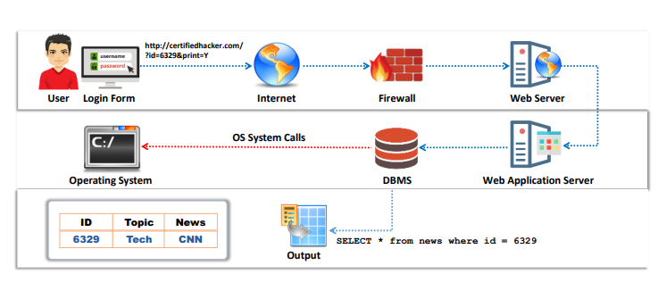

**Figure 4: Working of Web Application**

**Web Application Architecture**

* **Web Application Components:** Web applications run on browsers, employing server-side scripts (Java, C#, PHP) and client-side scripts (HTML, JavaScript) for execution.
* **Architecture Overview:** Comprising three layers - client, business logic, and database - it involves hardware and software tasks for handling requests, data retrieval, and presentation.
* **Client Layer:** Includes user devices like laptops, smartphones, and computers with compatible browsers that send requests. The web server responds, retrieving and displaying requested data in the browser as web pages.
* **Business Logic Layer:** Divided into web-server logic (firewall, request parser) and core business logic (implemented using .NET, Java). It manages data flow, and application logic, and integrates legacy systems.
* **Database Layer:** Incorporates cloud services, transactional layers, and database servers (e.g., MySQL) for storing and supplying structured data, catering to an organization's production needs. (Ethical Hacking Essentials, EC-Council).

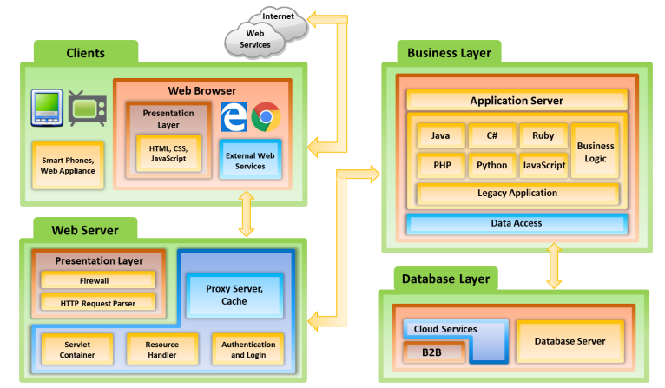

**Figure 5: Web Application Architecture**

**Web Services**

Web services are Internet-based applications that use message protocols such as SOAP to enable cross-platform communication between various applications. They facilitate interoperability across platforms such as Java and PHP by utilizing protocols such as SOAP, UDDI, WSDL, and REST, allowing for easy integration and interaction within a network context. (Ethical Hacking Essentials, EC-Council).

**Web Service Architecture**

Web service architecture orchestrates interactions between service providers, requesters, and registries via three critical operations: publishing, finding, and binding. Service providers publish service descriptions to a registry, which requesters can use to connect to and initiate web service deployment. Providers give services, requesters seek communication, and registries store service details for discovery. Operations include publishing descriptions, accessing interfaces and bindings, and creating runtime contact with binding data. Within this architecture, there are two major elements: services, which are software modules that provide communication, and service descriptions, which define the interfaces, locations, and bindings required for interaction and invocation. (Ethical Hacking Essentials, EC-Council). (Ethical Hacking Essentials, EC-Council).

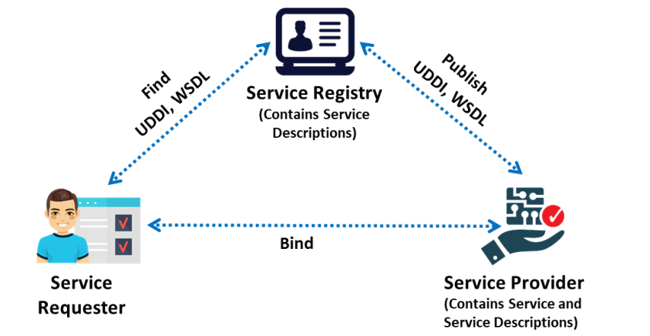

**Figure 6: Web Service Architecture**

**Characteristics of Web Services**

* **XML-based:** By avoiding OS or network-specific bindings, web services use XML for data representation and transmission, facilitating platform-independent communication and improving interoperability between applications.
* **Coarse-grained service:** Web services provide broader, more extensive functions by combining several fine-grained services into a single service entity. This promotes efficiency and lowers communication overhead.
* **Loosely connected:** By adopting a loosely coupled design, web services provide adaptive communication via XML messages, abstracting underlying infrastructure complexities, and enabling flexible system interaction through web APIs.
* **Seamless user experiences**: Seamless user experiences with both synchronous and asynchronous interactions are facilitated by web services, eliminating the need for users to wait for responses to support these various communication modalities, they use servlets, SOAP/XML, HTTP, and RPC-based or document-based messaging.
* **RPC support:** Remote procedure calls (RPC), which are similar to traditional applications but allow systems to initiate processes or functions remotely, are made possible by Web services. This improves the possibilities of distributed computing. (Ethical Hacking Essentials, EC-Council).

**Types of Web Services**

Web Services are of two types. They are:

* **SOAP Web Services:** The Simple Object Access Protocol (OAP) specifies an XML-based structure for data exchange between the requester and the service provider. Web services are constructed according to SOAP, which allows for standardized communication and cross-language data interchange.
* **RESTful Web Services:** Adopt the Representational State Transfer (REST) architecture and use HTTP principles to specify services. REST, as opposed to SOAP, is an architectural approach instead of a protocol that emphasizes efficiency and adaptability in client-server interactions by making use of current web standards. (Ethical Hacking Essentials, EC-Council).

**Web Application Threats and Attacks**

* **Injection** **Attacks**: Among the most common, these include SQL injection, NoSQL injection, and Command Injection. Attackers exploit vulnerabilities in input fields, injecting malicious code to manipulate databases or execute unauthorized commands.
* **Cross-Site Scripting (XSS):** Involves injecting malicious scripts into web pages viewed by other users. These scripts can steal sensitive data, redirect users to malicious sites, or hijack sessions.
* **Cross-Site Request Forgery (CSRF):** Exploits the trust a website has in a user's browser by making unauthorized requests on behalf of the user. Attackers trick users into unknowingly executing actions on a different site where they are authenticated.
* **Vulnerability in data protection:** Exposed vulnerabilities lead to Sensitive Data Exposure, a critical risk where applications falter in safeguarding crucial information such as passwords, credit card details, and personal data. This could result from poor encryption or inadequate security measures.
* **Security Misconfigurations:** Stemming from poor system setups or misconfigured security settings, these vulnerabilities offer attackers easy access to sensitive information or unauthorized functionalities.
* **Broken Authentication:** Weak authentication mechanisms, session management flaws, or predictable passwords enable attackers to compromise user accounts or gain unauthorized access.
* **XML External Entity (XXE) Attacks:** Target applications that parse XML input. Attackers exploit vulnerabilities to disclose confidential data, execute remote requests, or perform denial-of-service attacks.
* **Insecure Deserialization:** Attackers manipulate serialized objects exchanged between applications, executing arbitrary code, or tampering with data.
* **Server-Side Request Forgery (SSRF):** Exploits server-side functionalities to make requests from the server to other resources on behalf of the attacker, potentially accessing sensitive internal systems.
* **File Upload Vulnerabilities:** Attackers abuse flaws in file upload functionalities to upload malicious files, gain access or execute arbitrary code on the server. (Ethical Hacking Essentials, EC-Council).

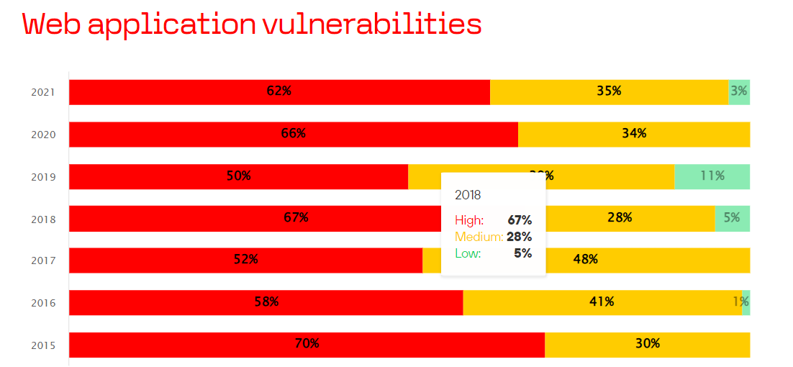



**Figure 7: Share of vulnerable web applications by maximum vulnerable severity**

**Web Application Attack Tools**

Web application attack tools encompass Metasploit for exploits, w3af for web vulnerabilities, Nikto for server scanning, Sn1per for automated assessment, and WSSiP for web service security.

* **Metasploit:** Empowering penetration testing through its robust framework, designed for the development, testing, and execution of exploits with precision.
* w3af: An open-source security scanner with plugins for detecting and addressing web vulnerabilities such as SQL injection and XSS.
* **Nikto:** It is a web server scanner that is noted for its complete vulnerability assessment capabilities and detailed findings.
* **Sn1per**: An automated reconnaissance tool for penetration testing that streamlines information collection and vulnerability searches.
* **WSSiP:** It is a Python-based web service scanner that identifies input validation errors and XML vulnerabilities to improve web service security. (Ethical Hacking Essentials, EC-Council).

**Web Application Attacks Countermeasures**

* **Input Validation:** Make sure that data complies with expected formats by validating and sanitizing user input to stop injection threats like SQL injection and XSS.
* **Output Encoding:** To mitigate cross-site scripting (XSS) vulnerabilities, encode output data to neutralize harmful scripts or code inserted by attackers.
* **Authentication and Authorization:** Use strong password policies and multi-factor authentication (MFA) as authentication mechanisms. Make sure the right authorization is in place before limiting access to sensitive features or information.
* **Session Management:** To avoid session hijacking or fixation, use secure session handling strategies like session timeouts, secure cookie properties, and unique session identifiers.
* **Security Headers:** To improve browser security and lessen specific kinds of attacks, make use of security headers like X-Frame-Options, Strict-Transport-Security (HSTS), and Content Security Policy (CSP).
* **Web application firewalls (WAFs) and firewalls:** Use firewalls and WAFs to monitor and filter incoming and outgoing traffic, preventing harmful requests and payloads.
* **Patch Management:** To fix known vulnerabilities and security risks, update and patch software, frameworks, and libraries regularly.
* **Secure Coding Practices:** To reduce vulnerabilities during the development phase, adhere to secure coding standards and best practices, conduct code reviews, and employ secure development frameworks.
* **Security Testing:** To find and fix vulnerabilities early on, do routine security assessments that include code analysis, vulnerability scanning, and penetration testing.
* **Education and Awareness:** To reduce social engineering attacks and foster a security-conscious culture, educate developers, administrators, and users on common threats, recommended practices, and security awareness.

These countermeasures collectively contribute to fortifying web applications against a spectrum of threats and vulnerabilities, enhancing overall security posture, and protecting against potential attacks. (Ethical Hacking Essentials, EC-Council).

**Web Application Security Testing Tools**

* **N-Stalker Web App Security Scanner:** It uses the 39,000-attack signature database of the N-Stealth HTTP Security Scanner to find vulnerabilities such as SQL injection and XSS. Because of its component-oriented evaluation method, developers, system/security administrators, and auditors can all benefit from it.
* **Acunetix WVS:** Well-known for its thorough scanning powers, Acunetix WVS finds a variety of vulnerabilities with accuracy. It is useful for safeguarding web apps since it gives thorough reports and ranks problems.
* **Browser Exploitation Framework (BeEF):** A pivotal tool in the hands of security experts, BeEF serves to evaluate the efficacy of defenses against browser-based vulnerabilities, ensuring a thorough assessment of web security measures.
* **Metasploit:** Metasploit is a comprehensive penetration testing tool that helps find security holes in networks. Security experts may simulate attacks and evaluate their network defenses with their range of exploitation tools and modules.
* **PowerSploit:** Post-exploitation situations are the main application for this GitHub-available tool. Its major objective is to support security researchers and penetration testers in their efforts to preserve access, escalate privileges, and obtain data following a successful breach.
* **Watcher:** A passive vulnerability scanner created by Casaba Security, Watcher is intended to find problems in online applications. It is a helpful tool for ongoing security monitoring since it tracks HTTP traffic and spots possible security issues.

Every tool has a distinct function and covers a range of web application security testing needs, from aggressive vulnerability scanning to passive monitoring and exploitation. (Ethical Hacking Essentials, EC-Council).

**Future Scope**

The field of cybersecurity is anticipated to experience several significant developments and difficulties shortly. The rise of AI-driven attacks, which use machine learning capabilities to perform complex evasive maneuvers against security procedures, is a worrying trend that necessitates creative protection tactics. Moreover, as Internet of Things (IoT) devices become more widely integrated, new vulnerabilities in web applications are being discovered, underscoring the necessity of stronger security measures to fend off such incursions. Investigating how blockchain technology might be used to strengthen security by guaranteeing tamper-proof transactions and decentralizing data storage presents encouraging opportunities for improving the robustness of online systems. Furthermore, due to the increasing complexity of API interactions, strong authentication and encryption techniques must be used to protect against any API security concerns and guarantee the integrity and confidentiality of data exchanges. These future trajectories call for proactive approaches and innovative solutions to fortify web application defenses against emerging threats and vulnerabilities. (<https://ieeexplore.ieee.org/>).

**Recommendations**

* Adaptive Security Measures: Use machine learning to defend against AI-based assaults by putting into practice dynamic and adaptive security techniques.
* Protection for IoT Devices: To protect web applications from the dangers posed by interconnected IoT devices, strengthen security mechanisms.
* API Security Protocols: To properly secure APIs, implement strict security procedures, such as robust authentication and encryption requirements.

Organizations can improve their overall cybersecurity posture by better defending against evolving web application assaults by anticipating these emerging patterns and implementing proactive security measures. (https://ieeexplore.ieee.org/).

**Conclusion**

The evolving landscape of web application security presents a persistent challenge with sophisticated threats exploiting vulnerabilities like SQL injection, XSS, and CSRF. Countermeasures use validation, encoding, rigorous authentication, and proactive testing to enhance defenses. Layered defense, user awareness, upgrades, and safe code are critical in this digital age. Combining these with advanced security technologies and continuous monitoring enables enterprises to confidently control the threat landscape. A proactive, comprehensive strategy incorporating preventive measures and timely reactions is required for effective web application security. It is the combination of proactive security and reactive agility that ensures user confidence, data safety, and continuous service availability in the face of continual security concerns. (<https://ieeexplore.ieee.org/>).

**References**

* <https://owasp.org/www-project-top-ten/>
* <https://www.sans.org>
* <https://csrc.nist.gov>
* <https://ieeexplore.ieee.org/document/9702496>
* <https://ieeexplore.ieee.org/document/6316697>
* <https://www.researchgate.net/publication/261389106_A_survey_on_web_application_vulnerabilities_and_countermeasures>
* <https://dl.acm.org/action/doSearch?AllField=web+application+attacks>
* <https://codered.eccouncil.org/course/ethical-hacking-essentials?logged=false>
* <https://trustnetinc.com/web-application-attacks/>